3. Car Booking Reservation System
Aim:
To develop a simple cloud-based SaaS application for searching and reserving cabs based on source, destination, rental type, package type, and duration.
Algorithm:
- Start the application and login/register the user.
- Enter the pickup location and destination.
- Select rental or out-station booking type.
- Select package type and required hours/days.
- Display available cabs and fare, then confirm the booking.
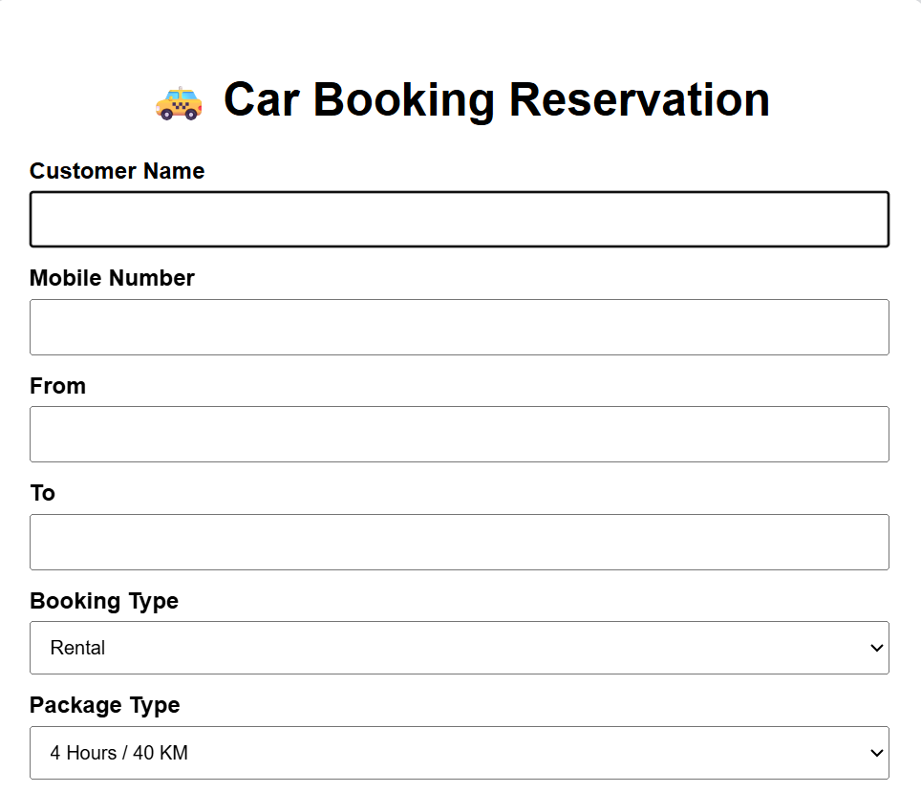

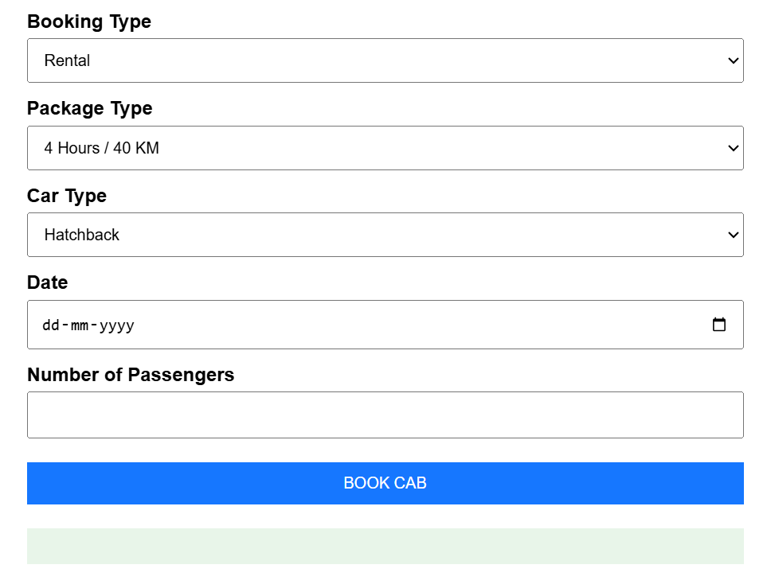
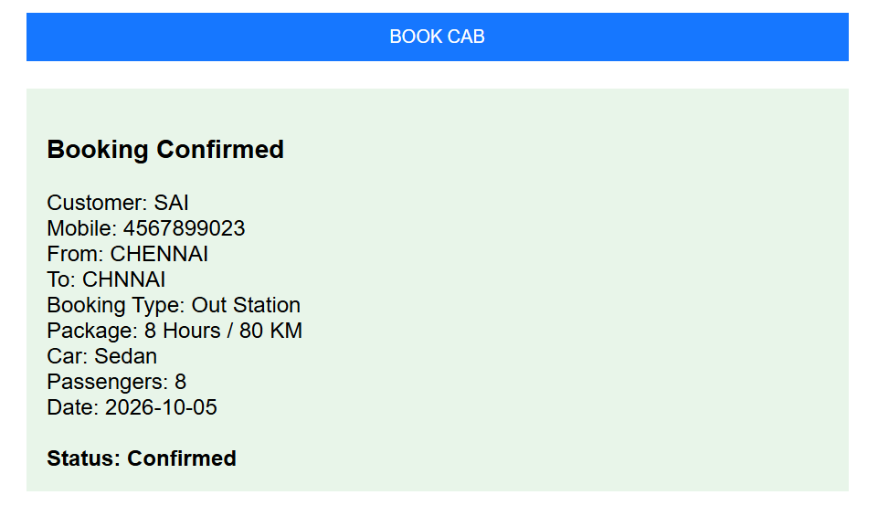Result:
A cloud-based car booking reservation system was successfully developed to search and reserve cabs online.

4. SIMATS Library Book Reservation System
Aim:
To develop a cloud-based SaaS application for searching and reserving books in the SIMATS library.
Algorithm:
- Start the application and login/register the student or librarian.
- Enter the book title, author, publication, year, or edition to search.
- Display book details, rack number, and available copies.
- Check the book status as available, taken, or returned.
- Reserve the available book and update the reservation status.
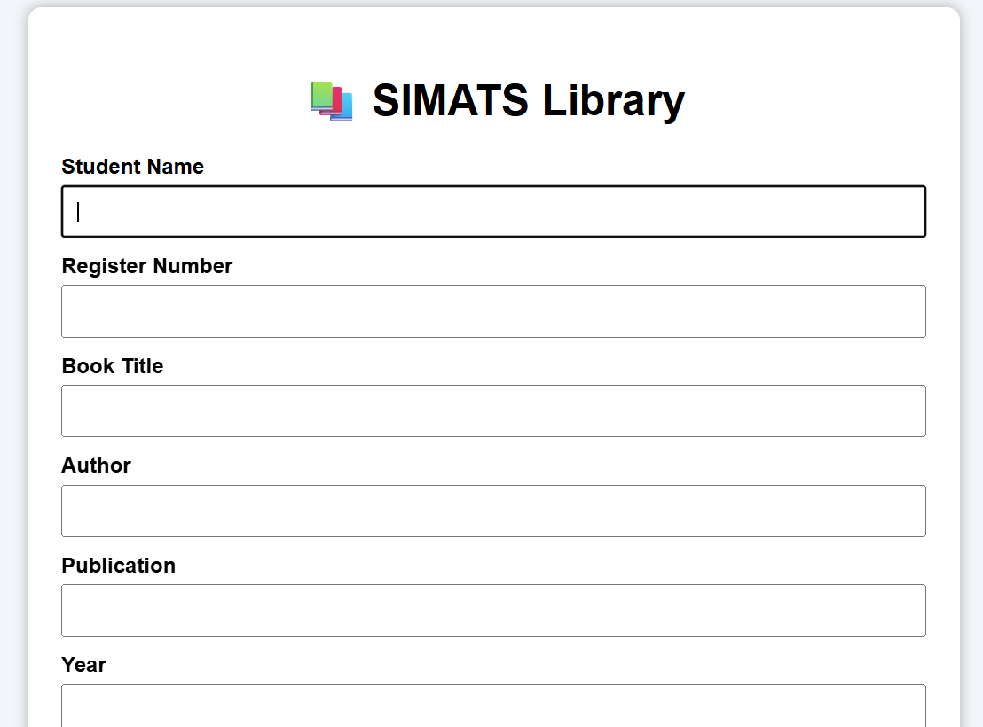
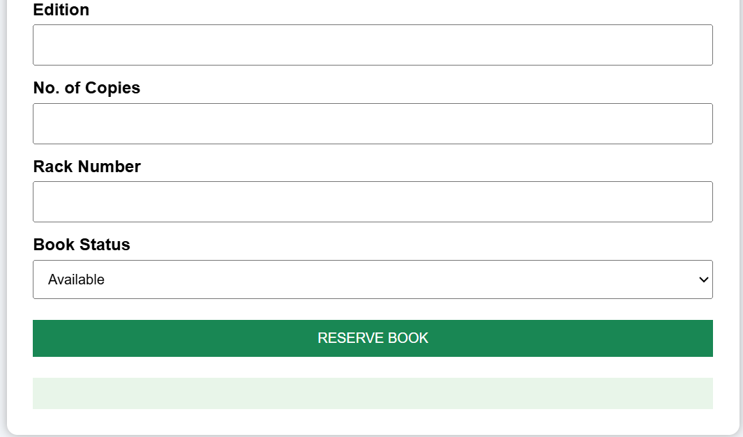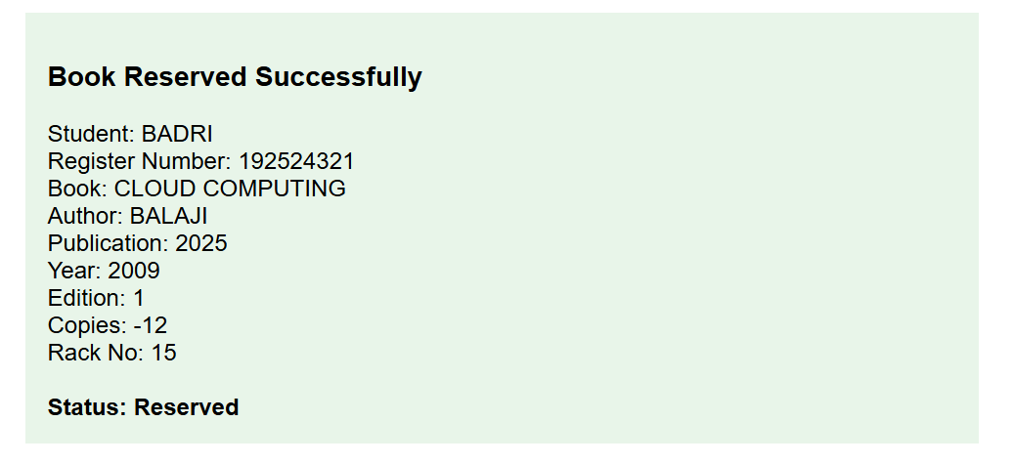Result:
A cloud-based SIMATS library book reservation system was successfully developed to search, reserve, and manage library books online.

5. Mark Sheet Processing System
Aim:
To develop a simple cloud-based SaaS application for processing student marks and calculating average, percentage, rank, and overall performance.
Algorithm:
- Enter the student name, register number, and subject marks.
- Calculate the total marks and average marks.
- Calculate the percentage based on the total marks.
- Determine the student's rank based on the percentage.
- Display the overall performance as Excellent, Good, Average, or Poor.
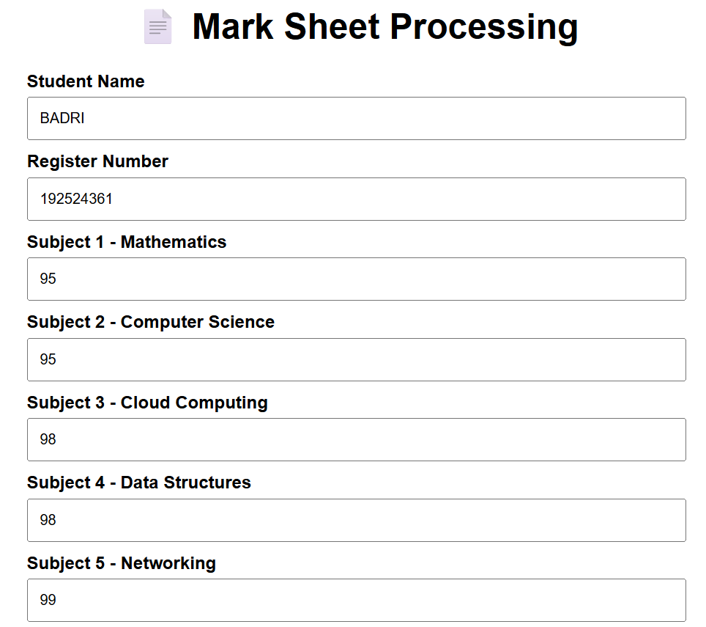

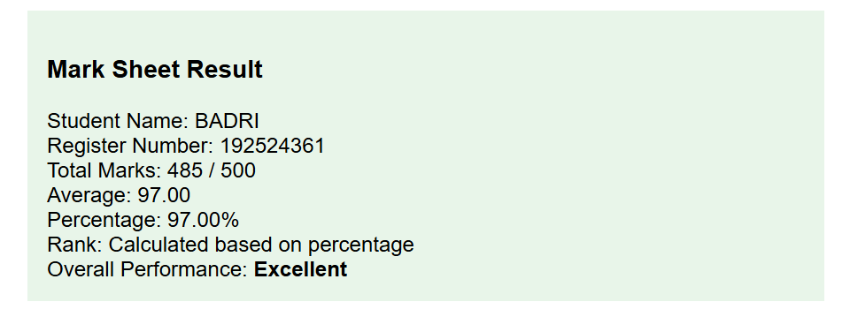Result:
A cloud-based mark sheet processing application was successfully developed to calculate total, average, percentage, rank, and overall student performance.

6. Payroll Processing System
Aim:
To develop a simple cloud-based SaaS application for processing employee payroll and calculating gross pay and net pay.
Algorithm:
- Enter employee name, present organization experience, and overall experience.
- Enter the employee's basic pay.
- Calculate HRA, DA, and TA based on the basic pay.
- Calculate gross pay by adding basic pay, HRA, DA, and TA.
- Calculate and display the net pay and payroll details.
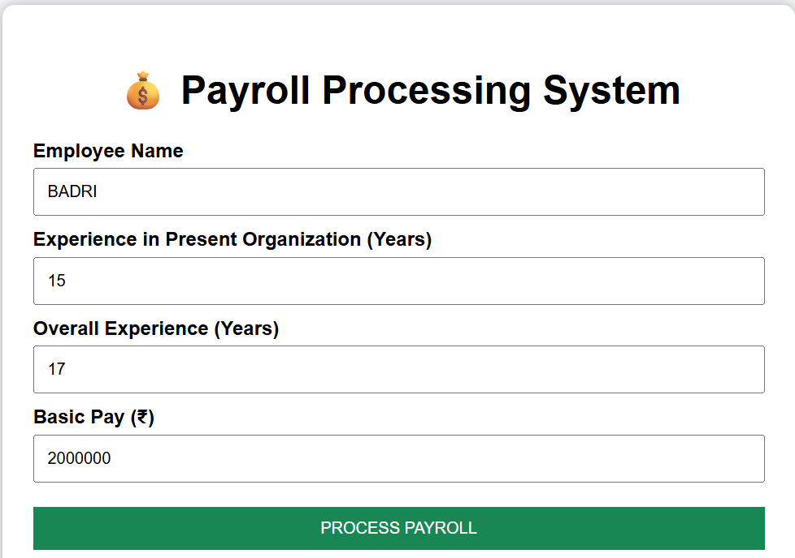

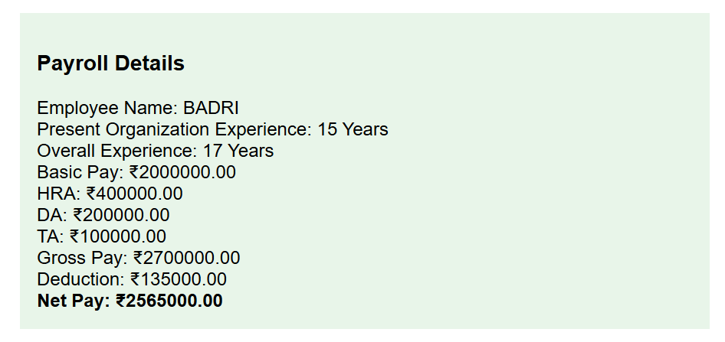
Result:
A cloud-based payroll processing application was successfully developed to calculate HRA, DA, TA, gross pay, deductions, and net pay.

